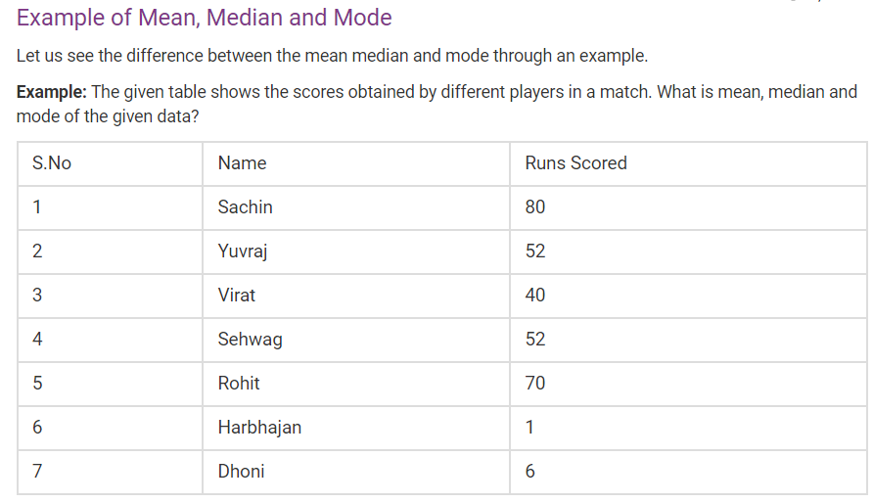

2.The points scored by a Kabaddi team in a series of matches are as follows:  
17, 2, 7, 27, 15, 5, 14, 8, 10, 24, 48, 10, 8, 7, 18, 28  
Find the mean, median and mode of the points scored by the team.

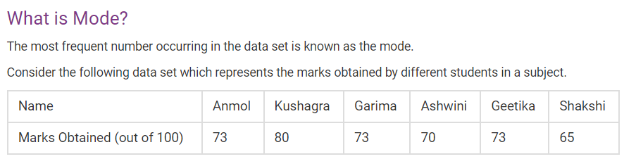

**Question:** Find the mean, median, mode and range for the given data:

90, 94, 53, 68, 79, 94, 53, 65, 87, 90, 70, 69, 65, 89, 85, 53, 47, 61, 27, 80

**Question 1:**Find the mean, median, mode, and range for the following list of values:

13, 18, 13, 14, 13, 16, 14, 21, 13

ANSWERS

1. MEAN=43, MEDIAN=52, MODE=52
2. MEAN=15.5, MEDIAN=12, MODE=7,8,10
3. MODE=73
4. MEAN=70.95, MEDIAN=69.5, MODE=5, RANGE=4
5. MEAN=15, MEDIAN=14, MODE=13, RANGE=3